CDA 4527: Computer Networking
Mid-Term Exam Solution

Prof. Cliff Zou
Oct. 11, 2007
Question 1: Knowledge questions (25points)

Answer each of the following questions briefly, i.e., in a few sentences.

a). What is the major differences between TCP and UDP? Why DNS uses UDP instead of TCP for its service?

(1). TCP is connection oriented, which needs to set up a connection first; UDP is connection-less and does not need to set up connection.
(2). TCP is reliable data transfer. UDP does not guarantee data to reach the destination reliably.
(3). TCP has flow control and congestion control; UDP does not.

DNS service is very short-lived: one-round of DNS service only needs the client to send one packet to query and the server to send back one packet for response (typically)----it takes only about one RTT time for the service. Using TCP will add another RTT time to set up TCP connection, which is very inefficient. UDP does not have this issue.

b). According to the course’s textbook, how many layers are included in the Internet (give their names too)? Give one example of application, or protocol, or device, that corresponding to each layer.

From top to down: Application layer (HTTP), transport layer (TCP), network layer (router), link layer (Ethernet), physical layer (optic fiber).

c). What does “TTL” mean? What is the usage of TTL in DNS resource record? What is the usage of TTL in packet IP header?

TTL is “time-to-live”.

In DNS resource record, “TTL” specifies the amount of time (in seconds) DNS servers and applications are allowed to cache the record.

In a packet IP header, TTL specifies the maximum routers the packet could pass through. Each router will decrease this value by 1 before sending it out, and drop a packet if it has a TTL=0. Traceroute program uses this property to measure network path and delay.

d). Suppose a web server has 10 ongoing TCP connections. How many server-side sockets are used? How many server-side port numbers are used? (Hint: remember the server implements fork() as introduced in lectures)

11 server-side sockets are used. One socket is used for listening on port 80. The other 10 sockets are created for each coming connection. Only one port number (80) is used.

e). What is the size of a TCP header? What is the size of a UDP header? What fields exist in both TCP header and UDP header?

TCP header has 20 bytes; UDP header has 8 bytes. The fields exist in both TCP header and UDP header are: checksum, source port, destination port.

f). What’s the differences between DSL and Cable Modem in terms of speed, shared or not shared media? Is the download speed bigger or upload speed bigger? Why?

DSL Cable Modem
Speed slow fast
Shared media no yes

Both have higher download speed than upload speed. This is because most home computers behave as clients to obtain information form servers in the Internet. Thus home computers upload fewer data than download data.

Question 2: TCP protocol and network traffic (20 points)

a). Suppose the TCP packet transmission between host A and host B follows the following scenario, fill in the missing sequence number and ack number.

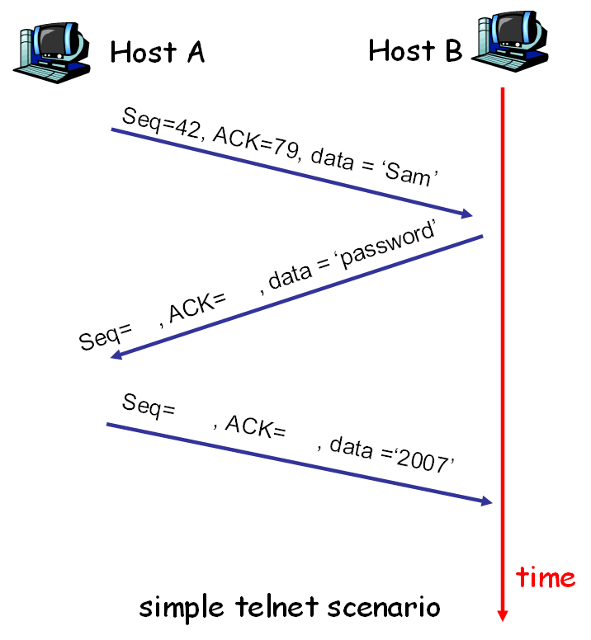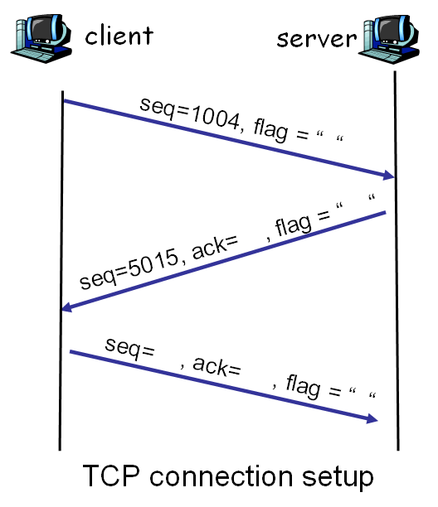

In the “simple telnet scenario”, the packet from B to A, Seq=79, Ack=45; the second packet from A to B, Seq=45, Ack=87.

In the “TCP connection setup”, first packet: flag=”SYN”. The second packet: ack=1005, flag=”SYN+ACK” (or write “SYN/ACK”). The third packet: seq=1005, ack=5016, flag=”ACK”

Question 3: DNS service (15 points)

Suppose you open a startup company “starwar” and want to set up your company network. Your network has the following servers:
- DNS server: “dns1.starwar.com” with IP as “128.119.12.40”
- Web server: “starwar.com” with two IP as “128.119.12.55” and “128.119.12.56”. The web server also has a name as “www.starwar.com”.
- Email server: “galaxy.starwar.com” with IP as “128.119.12.60”

Your company’s email address is “username@starwar.com”.
a). What resource records (RRs) do you need to provide to the upper-level “.com” Registrar?

(starwar.com, dns1.starwar.com, NS)
(dns1.starwar.com, 128.119.12.40, A)

b). What RRs do you need to put in your company’s DNS server?

(starwar.com, 128.119.12.55, A)
(starwar.com, 128.119.12.56, A)
(www.starwar.com, starwar.com, CNAME)
(galaxy.starwar.com, 128.119.12.60, A)
(starwar.com, galaxy.starwar.com, MX)

Question 4: A reliable data transfer protocol (20 points)

In class, we have seen a number of mechanisms used to provide for reliable data transfer:
- checksum
- ACKs
- timers
- sequence numbering
Consider a sender and receiver that are connected by a sender-to-receiver channel that can corrupt and lose packets. The receiver-to-sender channel is perfect (i.e., it will not lose or corrupt packets). Neither channel will reorder packets. [Note: re-read the channel properties just described and make sure you understand them!]

You are to design a reliable data transfer protocol (no pipeline, stop-and-wait style) for this scenario using only those mechanisms (among the four listed above) that are absolutely required. That is, if you use a mechanism that is not required, your answer will not be given full credit, even if the protocol works. Your protocol should be as simple as possible but have the functionality to reliably deliver data under the stated assumptions. Your solution need not be efficient; it must work correctly.

- Draw the sender and receiver FSMs.

Ignore the (2d) used in starttimer() function. We do not test on this item.

b). For each of the mechanisms (among the four listed above) that you use in your protocol, explain the role/purpose of the mechanism and why can’t you get by without it? If you do not use one mechanism, explain why you do not need it.
Because the sender-to-receiver channel can corrupt packets, the data-sent on the sender-to-receiver channel will need a checksum to detect bit errors. Because the sender-to-receiver channel can lose packets, we will need to have a timer to timeout and retransmit packets that have not been received by the receiver. The receiver will need to indicate which packets it has received by using an ACK message; if a packet is not received or is received corrupted, no ACK is sent. There is no need for sequence numbers, since there will be no unneeded (and unexpected at the receiver) retransmissions.

The FSM for the sender and receiver are shown below.

As an example of the mistakes in answers to watch out for:
- Do not need to use sequence numbers
- Do not need checksums on receiver-to-sender channel
- Separate FSMs are needed for the sender and the receiver!
- Do not need NAKs (absence of ACK serves as a NAK)

Question 5: Caching and delays (20 points)

Consider the networks shown in the figure below. Assume computers in the institution send out 14 requests per second. Each object average size is 100,000 bits. Also assume the internet side delay of a request is 2 seconds. Using M/M/1 queue to model the access delay in the 1.5Mbps access link. The formula for the average response time is E[T]=1/(μ-λ), where λ is the arrival rate of objects to the access link and μ is the service rate of the access link.
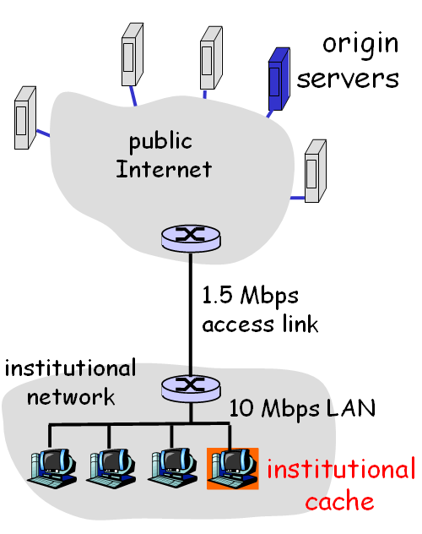

a). Find the total average response time when no institutional cache is used. [Note: you should also use the M/M/1 queue formula to calculate the delay in internal Ethernet LAN.]

For the Internet access link: λ=14/sec, μ=1.5Mbps/100,000bit = 15/sec. So the response time on the access link is: E[T_{access}] = 1/(μ-λ) = 1 second
For the local LAN: λ=14/sec, μ=10Mbps/100,000bit = 100/sec. So the response time on LAN is:
E[T_{LAN}] = 1/(μ-λ) = 0.0116 second

Thus the total average response time is:
E[T] = E[T_{access}] + Internet delay + LAN delay = 1 + 2+0.0116 = 3.0116 seconds

b). Now suppose the institutional cache is used. The hit rate for the cache is 0.8. Find the total average response time.

The local LAN delay does not change since its access rate is still 14/sec.
80% of requests hit cache and have their response time equal to local LAN delay, which is
E[T_{hit}] = E[T_{LAN}] = 0.0116 second.
20% of request not hit local cache and go out, thus the arrival rate on the access link is
λ=14*0.2 = 2.8/sec, μ is still μ=15/sec
The response time on the access link is E[T_{access}] = 1/(μ-λ) = 0.0820 second
Thus the average response time for requests going out is:
E[T_{miss}] = E[T_{access}] + Internet delay + LAN delay = 0.0820 + 2 + 0.0116 = 2.0936 seconds

Thus the total average response time is:
E[T] = 0.8* E[T_{hit}] + 0.2* E[T_{miss}] = 0.8*0.0116 + 0.2*2.0936 = 0.428 seconds

