1.5





d)

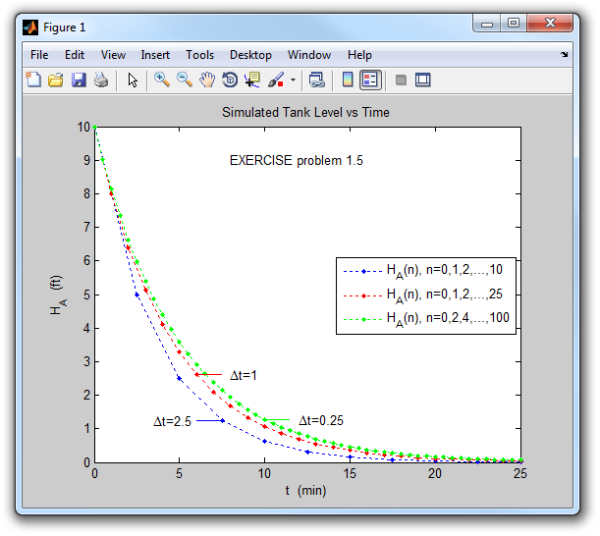

As expected, the smallest value of  produces the most accurate results, i.e. closest to the analytical solution  (not shown). However, more calculations are required to simulate the response for a fixed period of time.