CNT 4704: Analysis of Computer Communication Networks
Homework 1 (Fall 2013)
Assigned Sept. 25th; Due midnight Oct. 3rd via WebCourse
1. The advantage of packet switching vs. circuit switching. The following figure shows that many users are sharing a 1Mbps access link to the Internet. Suppose each user is either in active status that required data access rate of 120kbps, or in silence status that the user requires no data. Each user is active only 8% of the time; and users are independent with each other in their activities.
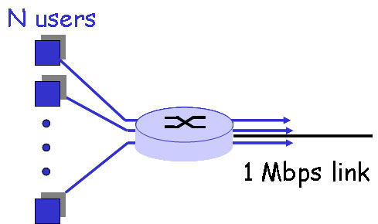
a). If circuit switching is used, how many users can this access link support (meaning that every user allowed in this network should be able to get his/her required bandwidth)?
b). If packet switching is used and there are 5 users. How often is this access link idle? How often does this link serve just 1 user?
b). If packet switching is used and there are 20 users, how often does the access link be congested? (Hint: the link is congested if and only if all active users’ combined required bandwidth is over the 1Mbps link capacity).
You can leave your answer in terms of an expression (e.g., with sums) to be evaluated (i.e., you need not provide the final numerical solution).
2. Perform "traceroute" from your computer at home (not do it in campus!) to http://www.ifi.uzh.ch/index.html (If use Windows, please use tracert). If you live in student dorm inside campus network, you are allowed to use the online traceroute http://www.tracert.org/traceroute/ to do the traceroute.
a). Copy the traceroute report in your homework.
b). find out the two edge routers that in between lies the Atlantic Ocean line.
b). Try to identify the regions or ISP networks that the traceroute packets pass through from the source to the destination.
3. True or false? If a statement is false, explain briefly why it is wrong:
a). A user requests a Web page that consists of some text and 3 images. For this page, the client will send one request message and receive 4 response messages.
b). Two distinct Web pages (e.g., www.mit.edu/research.html and www.mit.edu/students.html) can be sent over the same persistent connection when using HTTP/1.1.
c). With non-persistent connections between browser and origin server, it is possible for a single TCP segment to carry two distinct HTTP request messages.
d). The Date: header in the HTTP response message indicates when the object in the response was last modified.
4. Suppose you open a startup company "flashNet" and want to set up your company network. Your network has the following servers:
- DNS server: "thounder.flashNet.com" with IP as "128.119.1.44"
- Web server: "flashNet.com" with two IP as "128.119.1.55" and "128.119.1.56". The webserver can also be access by URL “web.flashNet.com”.
- Email server: "lightning.flashNet.com" with IP as "128.119.1.60"
Your company's email address is "username@flashNet.com".
a). What resource records (RRs) do you need to provide to the upper-level ".com" Registrar?
b). What RRs do you need to put in your company's DNS server?
5. Consider the network shown in the figure below. Assume computers in the institution send out 7 requests per second. Each object responded by webservers has an average size of 200 kbits. Also assume the internet-side delay of a request is 1.5 seconds (i.e., the RTT between the Internet-side router and an Internet web server). The 1.5Mbps access link has the average delay time for an object on the access link as T = 1/(x-y), where y is the arrival rate of objects to the access link and x is the service rate of the access link (i.e., on average, the access link could server x objects per second). We also assume there is no delay for requests going out of the access link, and assume there is no delay on the local Ethernet LAN.
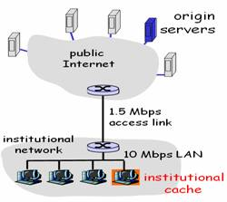
Internet-side router
1Gbps Ethernet LAN
a). Find the total average response time when no institutional cache is used. (Hint: total delay includes Internet delay plus access link delay)
b). Now suppose the institutional cache is used. The hit rate for the cache is 0.5. Find the total average response time.

