CNT 4704: Analysis of Computer Communication Networks
Homework 3: Networking Layer (Fall 2013)
Assigned Nov. 6th; Due midnight Nov. 20th via WebCourse
1. (10 points) What are the three major routing protocols used in Internet? Give their full name and their acronym. Which protocol is mainly based on link-sate algorithm? Which protocol is mainly based on distance vector algorithm?

2. (15 points) Consider a datagram network using 8-bit host addresses. Suppose a router uses longest prefix matching and has the following forwarding table:
Prefix Match | Interface
00 | 0
010 | 1
011 | 2
10 | 2
11 | 3
For each of the four interfaces, give the associated range of destination host address and the number of addresses in the range.

3. (15 points) A /23 block of addresses is granted to a small organization. We know that one of the addresses is 129.118.40.12. How many IP addresses are contained in this subnet? What is its x.y.z.t/n representation?

4. (20 points) Consider a router that interconnects three subnets: Subnet 1, Subnet 2, and Subnet 3. Suppose all of the interfaces in each of these three subnets are required to be within the IP range of 114.115.127.0/24. And also suppose IP addresses in these 3 subnets need to have the relationship of Subnet1 < Subnet2 < Subnet3. Subnet 1 is required to support at least 60 interfaces, Subnet 2 is to support no smaller than 95 interfaces, and Subnet 3 is to support at least 14 interfaces. Provide these three subnets in the format of a.b.c.d/x that satisfy these constraints.
5. (20 points) Link State Algorithm: Considering the following network. With the indicated link cost, use Dijkstra's shortest path algorithm to compute the shortest paths from node t to all other nodes. You need to show how the algorithm works by computing a table similar to the table shown in Page 23 in Chapter4-part2.ppt.
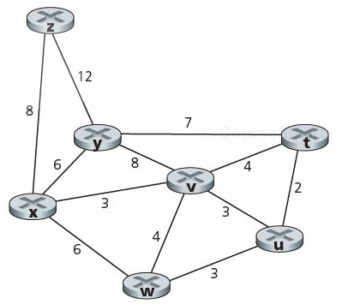
6. (20 points) Distance Vector Routing: Consider the network shown below, and assume that each node initially knows the costs to each of its neighbors. Assume all nodes receive their neighbors' update message at the same time and update their own distance table at the same time (similar to the example shown in Page 32,33 in Chapter4-part2.ppt). Show the distance table update procedure in the similar way as Page 33 in Chapter4-part2.ppt.
