COP 3503 – Computer Science II – CLASS NOTES - DAY #12

Randomization

Introduction

Random numbers are an important part of the modern world of computing. Cryptography, simulation, and system testing all rely on random number generation. This set of notes deals with the generation and use of random numbers.

Important Uses of Random Numbers

program testing - suppose we want to test a sorting algorithm by running 5000 iterations of the program on input arrays of 1000, 10000, and 100000 elements – to do this we need to generate random data sets. Once we have generated the test data and run the sort algorithm how do we know it works properly? One way is to test if the numbers in the array are arranged in increasing order (this requires a linear time algorithm to do this verification) – but how do we know that the numbers in the final sorted array are the same numbers that were in the original unsorted array? How this can be accomplished in the explained in the next bullet.

- random permutations – a random permutation of the first N integers is a sequence of N integers that contains each of 1, 2, …, N exactly once. This can be fast technique for determining if a sort algorithm works, since regardless of the permutation chosen as the input sequence the sorted output sequence will always be 1, 2, …, N.

- efficiency comparison – useful for running algorithms repeatedly for determining running times.

- simulations – generates random events. Example, in testing operating systems, determining the average waiting time of a process can be determined by simulation of random arrival of processes to the system.

- randomized algorithms – a random number is used to determine which step in the algorithm will be performed next. This is common when the algorithm involves (at any step) a selection amongst several alternatives that are more or less indistinguishable. For example, most commercial chess games have the system’s first move made at random rather than deterministically (always the same first move).
Random Numbers and Pseudo-random Numbers

You probably already have some idea of what mean when we say that a number is random. The question of exactly what should be the criteria for a sequence of numbers to be random, is a very difficult one to answer. we might say, for example, that a random sequence of 0s and 1s, would be a sequence generated by repeatedly tossing a fair coin and recording a 0 for each head and a 1 for each tail. The problem with this definition is that it implies the sequence 00000000… is random, and further, that it is no more likely or less likely than any other sequence of 0s and 1s. It is probably more useful at this point to consider a sequence as random if knowing the first n terms of the sequence, we are not able to predict (with 100% accuracy) the (n+1)st term.

This unpredictability condition however, leads to big problems when you attempt to use a computer to generate random sequences. Computers are deterministic, meaning that their behavior is at any time is completely predictable based upon its prior behavior. Within the realm of computer generated random numbers and random sequences, we must be content with pseudo-random numbers. A pseudo-random number or sequence “appears” to be random, but in reality is not. For a pseudo-random sequence to be acceptable for use in place of a truly random sequence, the pseudo-random sequence must pass a sufficient number of statistical tests that would also be passed by the truly random sequence. If the pseudo-random sequence fails to pass the same set of tests, then the numbers within the pseudo-random sequence are not sufficiently random to be useful for the purpose at hand. Such a test might be that of all the numbers in the sequence occur equally often. This would imply that if we generated the digits 0…9 randomly, that after n digits had been generated, we would expect to see about n/10 of the number 3 in the sequence (similar number for each digit). As n grows, we would expect the number of 3 digits seen to approach exactly n/10. A sequence with this property is said to be equidistributed. Clearly this test is not sufficient to indicate a truly random sequence, since 012345678901234567890123456789… is equidistributed, but seems decidedly non-random. We could then further strengthen our statistical tests and require that any pairs of adjacent terms occur about 1% of the time, or perhaps that the subsequence formed by taking every other term or every fifth term be equidistributed. The bottom line is that there is no agreement about what should constitute the criteria for defining a pseudo-random sequence. If the statistical tests are too lenient or too few, then the door is left open for sequences that we would not want to include. If the tests are too strict or too numerous, then we may find that we are unable to generate a sequence which will pass all of our tests.

How are Random Numbers Generated?

Easier said than done!
- Use the system clock – simulate a coin toss – if the clock is even then heads (0), if the clock is odd then tails (1). PROBLEMS: (a) the entire program may finish before the clock changes value depending upon the granularity of the clock tick. (b) the program will be cyclic in nature (very repetitive) and thus the numbers will not appear random at all – (i.e., the time between calls to the clock will be essentially the same).
- What we want is a sequence of pseudorandom numbers between 0..999 with a uniform distribution. [In a uniform distribution, any number within the specified range has equal probability of occurring]

Uniform Distribution of Random Numbers

A uniform distribution of numbers from the range 0..999 has the following properties:

Weak properties:
- The first number is equally likely to be 0, 1, 2, …, 999.
- The i^{th} number is equally likely to be 0, 1, 2, …, 999.
- The expected average of all the generated numbers is 499.5

We could generate a sequence of random numbers that satisfy these properties by getting an initial clock time in milliseconds and adding one to this number on each successive call (although this won’t be very random).

Stronger properties:
- The sum of two consecutive random numbers is equally likely to be even or odd. [The clock technique fails this property since the sum of two consecutive numbers is always odd.]
- If 1000 random numbers are chosen, some of them will be duplicates and about 368 of them will not appear (in range 0..999). [The clock idea fails this property since the numbers are sequential.]

- All pseudorandom number generators will fail some statistical test (see the stronger properties in the box above).

- The better the pseudorandom number generator – the fewer statistical tests it will fail. [i.e., the good ones fail the fewest tests.]

Examples of Commonly Used Statistical Tests

- Frequency tests - These tests typically use either chi-square or Kolmogorov-Smirnoff tests to compare the distribution of the set of numbers generated against a uniform distribution.
- Serial tests – Tests which tally the frequency of occurrence of all possible combinations of 2, 3, 4, …, digits and then runs a chi-square test against expectations.
- Gap tests – Count the number of digits that appear between repetitions of a particular digit and then uses a chi-square test against expectations.
- Runs tests – Test the number of runs above and below some constant (usually the mean) or runs up and down. The tests typically involve counting the actual number of occurrences of runs of different lengths and comparing these counts to expectations by chi-square testing.
- Spectral tests – Measure the independence of adjacent sets of numbers based upon Fourier analysis. Knuth classifies this type of testing to be among the most discriminating known, i.e., assures very random numbers.
- Poker tests – Analogous to testing poker hands, these tests count combinations of five or more digits for all digits different, one pair, two pairs, three of a kind, full house, etc., and then tests against expected occurrences.
- Autocorrelation tests – Tests the correlation between X_{n} and X_{n+k} where k is the lag in the generation order (k = 1, 2, 3, …).
- Distance tests – Successive pairs of random numbers are regarded as coordinates for points in the unit square, and the square of the distance between the two points is tested against theoretical probabilities given by a set of equations.
- Order Statistic Tests – These test the maximum or minimum value of n consecutive numbers or the range of n consecutive values.

Linear Congruential Generator (LCG)
- The LCG is a multiplicative method and is a specific instance of a more general class of congruent generators. A congruent method is an arithmetic procedure which generates a finite sequence of uniformly distributed numbers. Two integer numbers A and B are said to be congruent modulo m iff there is an integer k such that A-B = km. In other words, if (A-B) is divisible by m and if A and B leave identical remainders when divided by m. This defining relationship is expressed as A ≡ B(mod m), which is read, “A is congruent to B modulo m.”
- A simple random number generator that passes a reasonable number of statistical tests. Defined in 1951.
- Not the best generator, but it is suitable for use in applications in which a good approximation to a random sequence is acceptable.
- Generates numbers X₁, X₂, … which satisfy X_{i+1} = AX_{i} (mod M) where A and M are constants.
- [The (i+1)th number is generated by multiplying the ith number by some constant A and computing the remainder when the result is divided by M.]
- All generated numbers will be smaller than M.
- X₀ is the seed. The seed is the initial number selected to begin the sequence. [Note: if X₀ = 0 then the sequence is not random – it is all 0s.]
- If A and M are carefully chosen, then any seed (1 ≤ X₀ ≤ M) is equally valid.
- If M is a prime number, then X_{i} is never 0.
- Generating a number for the second time results in a repeating sequence.
- The period is the length of a sequence before it repeats (its length with no repeated values).
- If M is a prime number then several choices for A will result in a full period. A full period results when the sequence contains all (M-1) possible values in the sequence.
- Any random number generator that produces a full period is called a full-period linear congruential generator.

The following examples illustrate how the LCG works.

Example
let M = 11, A = 7 with seed X₀ = 1.

X₀ = 1
X₁ = 7(1)(mod 11) = 7 mod 11 = 7
X₂ = 7(7)(mod 11) = 49 mod 11 = 5
X₃ = 7(5)(mod 11) = 35 mod 11 = 2
X₄ = 7(2)(mod 11) = 14 mod 11 = 3
X₅ = 7(3)(mod 11) = 21 mod 11 = 10
X₆ = 7(10)(mod 11) = 70 mod 11 = 4
X₇ = 7(4)(mod 11) = 28 mod 11 = 6
X₈ = 7(6)(mod 11) = 42 mod 11 = 9
X₉ = 7(9)(mod 11) = 63 mod 11 = 8
X₁₀ = 7(8)(mod 11) = 56 mod 11 = 1
X₁₁ = 7(1)(mod 11) = 7 mod 11 = 7
X₁₂ = 7(7)(mod 11) = 49 mod 11 = 5
…
Notice that the sequence repeats beginning with X₁₀ so the period is M-1 = 10 or 10 random numbers were generated.

A Second Example

If A = 5 and X₀ = 1 then the period is only 5

let M = 11, A = 5 with seed X₀ = 1.
X₀ = 1
X₁ = 5(1)(mod 11) = 5 mod 11 = 5
X₂ = 5(5)(mod 11) = 25 mod 11 = 3
X₃ = 5(3)(mod 11) = 15 mod 11 = 4
X₄ = 5(4)(mod 11) = 20 mod 11 = 9
X₅ = 5(9)(mod 11) = 45 mod 11 = 1
X₆ = 5(1)(mod 11) = 5 mod 11 = 5
X₇ = 5(5)(mod 11) = 25 mod 11 = 3

As the above examples illustrate – there are clearly good and bad choices to be made amongst the values of A, M, and X₀.
- M chosen to be a large 31-bit prime number should be sufficiently large for most applications. This 31 bit prime number is M = 2³¹ – 1 = 2,147,483,647. For this value of M, there a many values of A that give a full-period linear congruential generator, one of these is A = 48,271.
- Implementation of this algorithm is easy. However, using 32 bit numbers the value of A*X_{i} is almost certain to cause an overflow condition. While the overflow allows randomness it does not allow for a full-period and is thus unacceptable.
- This problem can be fixed with a slight reordering of the equation to generate the random number as follows:
Let Q be the quotient of M/A and R be the remainder of M/A, then the original equation: X_{i+1} = AX_{i} (mod M) becomes:
where the following holds:
- the first term can always be evaluated without overflow.
- the second term can be evaluated without overflow if R < Q
- δ(X_{i}) evaluates to 0 if the result of the subtraction of the first two terms is positive. It evaluates to 1 if the result of the subtraction is negative.

If M = 2,147,384,647 and A = 48,271 then Q = 44,488 and R = 3399

Implementation of the LCG Random Number Generator

assumptions: A,M,Q, and R are all constants
state = static/global variable = 1

int RandomIn ( )
{ int temp;
temp = A*(state mod Q) – R*(state/Q);
if (temp > 0)
state = temp;
else
state = temp + M;
return state;
}

Slightly Different Approach to the LCG

To generate the sequence X₀, X₁, X₂, … randomly chosen between 0 and m-1, begin with the seed X₀, and generate the remainder of the sequence according to the rule: X_{n+1} = (AX_{n} + B) mod m.

For example, chosing A = 3, B = 1, and m = 8, with X₀ = 3, we would generate the sequence:
X₀ = 3
X₁ = [3(3) + 1] mod 8 = 10 mod 8 = 2
X₂ = [3(2) + 1] mod 8 = 7 mod 8 = 7
X₃ = [3(7) + 1] mod 8 = 22 mod 8 = 6
X₄ = [3(6) +1] mod 8 = 19 mod 8 = 3
At which point the sequence repeats with this pattern forever.

Chosing A = 3, B = 1, and m = 8, with X₀ = 1, the generated sequence is:
X₀ = 1
X₁ = [3(1) + 1] mod 8 = 4 mod 8 = 4
X₂ = [3(4) + 1] mod 8 = 13 mod 8 = 5
X₃ = [3(5) + 1] mod 8 = 16 mod 8 = 0
X₄ = [3(0) +1] mod 8 = 1 mod 8 = 1
At which point the sequence repeats with this pattern forever.

This example illustrates two different sequences, both with periods of 4. Clearly, these sequences are both too short to be of much practical value, and neither of the sequences utilize all of the possible numbers 0…m-1. Many possible choices for A and B, given a fixed value for m, will not yield full periods. Two such cases that do have full periods are:

X_{n+1} = (11,549X_{n} + 3461) mod 16,384

and X_{n+1} = (9757X_{n} + 6925) mod 32,768

For both of these, the periods are full and for any value of X₀ they will generate all m possible numbers before repeating.

Probability Distributions

One way to generate numbers randomly in the range 0…5 would be to take five fair coins, toss them into the air, and record the number of heads that came up when they landed. This process certainly seems to be random, at least in the sense that we would have no way of predicting the next number that would be generated by this technique. However, you would find that this technique tends to produce the number 3 much more often than it does 0 or 5 (the same will be true for the number 2). Why is this so? The reason is that of the total number of 32 different ways that 5 coins can be arranged, fully 10 of these involve 3 heads (0s) and 2 tails (1s). This is illustrated below, showing all possible ways in which the five coins can land.

00000 = 5H,0T 01001 = 3H,2T 10010 = 3H,2T 11011 = 1H,4T
00001 = 4H,1T 01010 = 3H,2T 10011 = 2H,3T 11100 = 2H,3T
00010 = 4H,1T 01011 = 2H,3T 10100 = 3H,2T 11101 = 1H,4T
00011 = 3H,2T 01100 = 3H,2T 10101 = 2H,3T 11110 = 1H,4T
00100 = 4H,1T 01101 = 2H.3T 10110 = 2H,3T 11111 = 0H,5T
00101 = 3H,2T 01110 = 2H,3T 10111 = 1H,4T
00110 = 3H,2T 01111 = 1H,4T 11000 = 3H,2T
00111 = 2H,3T 10000 = 4H,1T 11001 = 2H,3T
01000 = 4H,1T 10001 = 3H,2T 11010 = 2H,3T

Total number of combinations with 0H = 1 [this is C(5,0)]
Total number of combinations with 1H = 5 [this is C(5,1)]
Total number of combinations with 2H = 10 [this is C(5,2)]
Total number of combinations with 3H = 10 [this is C(5,3)]
Total number of combinations with 4H = 5 [this is C(5,4)]
Total number of combinations with 5H = 1 [this is C(5,5)]

C(n,k) = 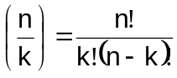

C(5,0) = 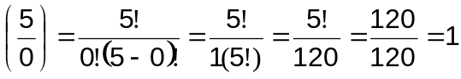

C(5,1) = 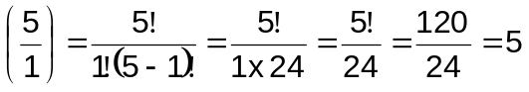

C(5,2) = 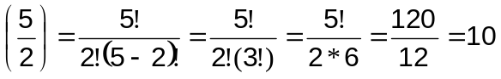

C(5,3) = 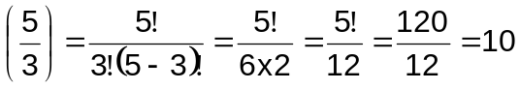

C(5,4) = 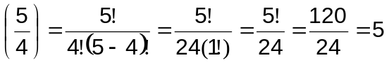

C(5,5) = 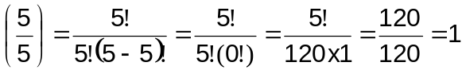

If you were to plot the values of a random variable x, which represents the number of heads that occurred on each coin toss, for a sufficiently large number of tosses, the scale of the number of occurrences of each value of x (this would be a plot of the frequency of occurrence of each value f(x) relative to the total number of tosses N) would depend entirely upon the total number of tosses that you made. Clearly, plotting the probability of each possible value would be better, since the probability will always lie between 0 and 1.

The probability is: p(x) = f(x)/N

Suppose that x is a random variable that can assume any value from the set:
{x₁, x₂, x₃, …, x_{n}} and suppose that the probability that x is equal to x_{i} is given by the function: p(x_{i} ), for i = 1,2, …,n, and that we have the sum p(x₁) +…+p(x_{n}) = 1. Then p is a discrete probability function for the random variable x. The set of values for x, along with the probability function for x, is called the distribution of x.

As an example, consider the early coin toss problem involving the five coins. Assume that we toss the five coins exactly 50 times (N=50) and that we get the following values for f(x): 0 heads occurs 3 times, 1 head occurs 7 times, 2 heads occurs 13 times, 3 heads occurs 15 times, 4 heads occurs 11 times, and 5 heads occurs exactly once.

Thus, f(0) = 3, f(1) = 7, f(2) = 13, f(3) =15, f(4) = 11, and f(5) = 1

This gives: p(0) = f(0)/N = 3/50 = 0.06
p(1) = f(1)/N = 7/50 = 0.14
p(2) = f(2)/N = 13/50 = 0.26
p(3) = f(3)/N = 15/50 = 0.30
p(4) = f(4)/N = 11/50 = 0.22
p(5) = f(5)/N = 1/50 = 0.02

For any distribution where the set of values is a set of numbers, there are two measures that provide some information about how the random variable behaves. The mean, of a distribution is the sum of the possible values, weighted by their probabilities. The mean represents the “average” value of the distribution. The mean is given by:

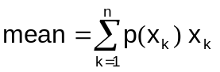

For the example above the mean is:

= (0.06 × 0) + (0.14 × 1) + (0.26 × 2) + (0.30 × 3) + (0.22 × 4) + (0.02 × 5)
= 0 + .14 + .52 + .90 + .88 + .10
= 2.54

The standard deviation (denoted by σ ) is the square root of the weighted sum of the squares of the differences between the values and the mean. Basically, the standard deviation represents how closely the values are clustered about the mean. A small standard deviation indicates that the values tend to be clustered very tightly around the mean, while a large standard deviation indicates the values less tightly clustered around the mean. The standard deviation is given by:

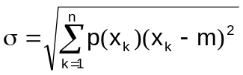

For the above example the standard deviation is:

= [(0.06)(0-2.54)² + (0.14)(1-2.54)² + (0.26)(2-2.54)² + (0.30)(3-2.54)² +
(0.22)(4-2.54)² + (0.02)(5-2.54)²]^{1/2}

= [(0.06)(6.4516) + (0.14)(2.3716) + (0.26)(0.2916) + (0.30)(0.2116) +
(0.22)(2.1316) + (0.02)(6.0516)]^{1/2}

= [0.387096 + 0.332024 + 0.075816 + 0.06348 + 0.468952 + 0.121032]^{1/2}

= [1.4484]^{1/2} = 1.20349

This means that the expected value for x is between 2 and 3 (2.54±1.20) and that the values are clustered somewhat closely around the mean.

Uniform Distribution
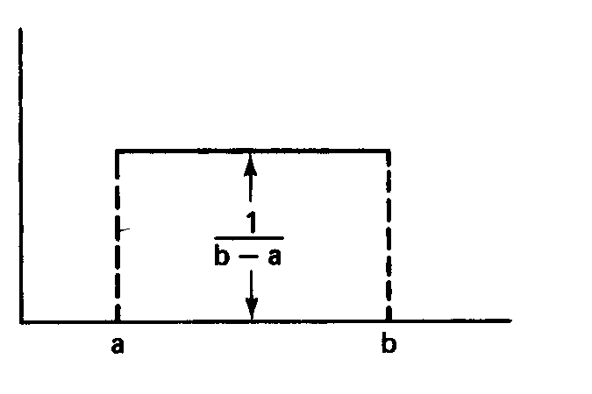

The diagram above illustrates a uniform distribution. A uniform distribution is a continuous probability function, which is constant over the defining interval from a to b and zero over all other regions. The mean and variance are given by:

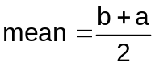 variance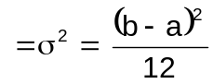

Poisson Distribution

The diagram above illustrates a Poisson distribution. The Poisson distribution can be used to model a number of real world situations. If you take a number of independent trials (go/no-go, success/failure, etc.), each having a small probability of occurring, then as the number n increases, the probability of x occurrences of the event occurring is given by a Poisson distribution. Thus you can model the number of forest fires, tornadoes, hurricanes, etc., per time period using a Poisson distribution. The Poisson distribution is fairly closely related to the exponential distribution discussed below.

Exponential Distribution

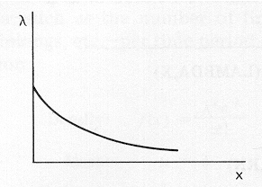

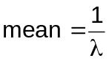

variance = 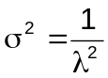

The diagram above illustrates an exponential distribution. If the probability that an event will occur during a small time interval Δt is very small, and if the occurrence of this event is independent of the occurrence of other events, then the time interval between the occurrence of events is exponentially distributed. For example, if in a queueing situation the arrival of customers is Poisson distributed with a mean = λ, then the time between arrivals is exponentially distributed with a mean = θ, where θ = 1/λ. Many events have exponential distributions, such as, the length of telephone conversations, lifetime of many electronic components, arrival of orders at an order terminal, etc.

Normal Distribution

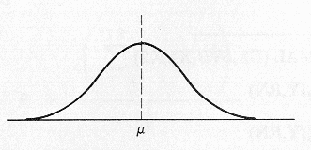

The figure above illustrates a normal or Gaussian distribution.

